Feature selection results for big_dataset and Nmin = 10

Data1 = označava single peak emisije
1. result: (signal_strength, peak_frequency, amp_of_peak_frequency)
Estimated Epsilon: 0.0062405, Picked Epsilon: 0.021241, MinNumPoints: 10
DBCV index value: 0.97041
cluster -1 had 1.3115% single peaks
cluster 1 had 97.0492% single peaks
cluster 2 had 1.3115% single peaks
cluster 3 had 0% single peaks
cluster 4 had 0% single peaks
cluster 5 had 0.32787% single peaks
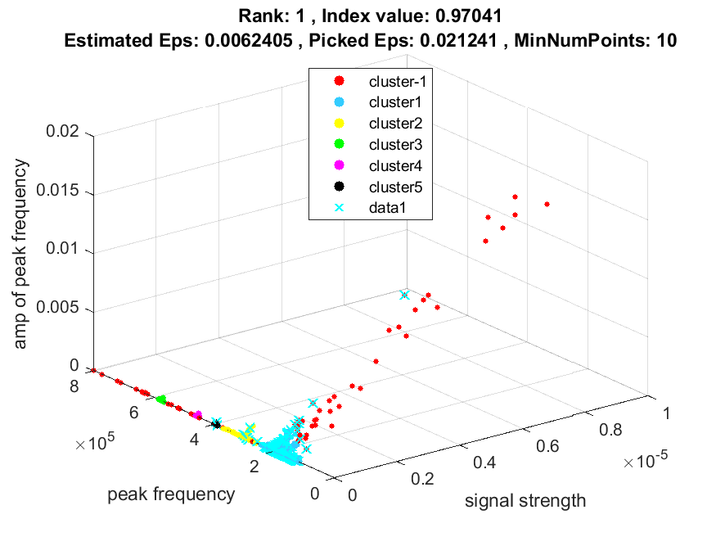
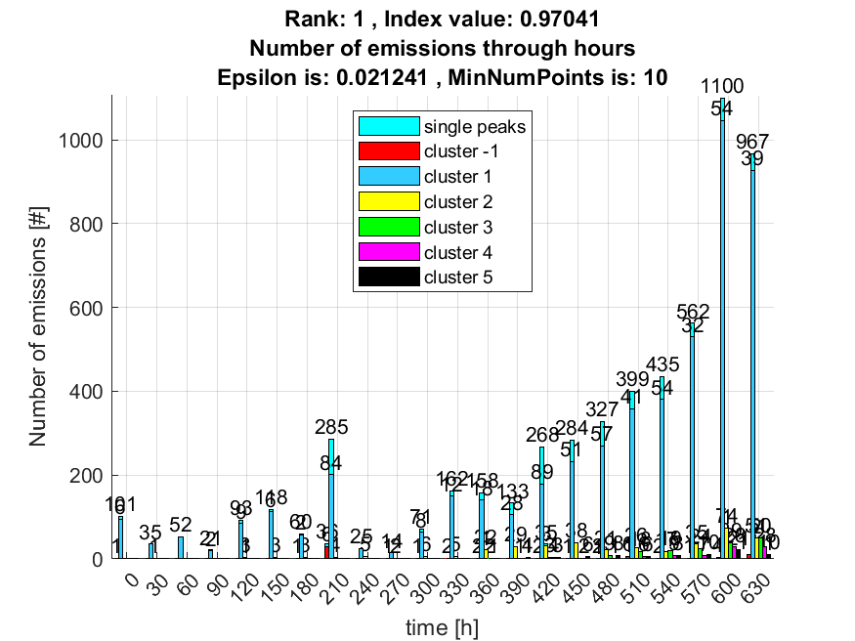

2. result: (peak_amplitude, peak_frequency, amp_of_peak_frequency)
Estimated Epsilon: 0.0085671, Picked Epsilon: 0.021067, MinNumPoints: 10
DBCV index value: 0.96633
cluster -1 had 1.6393% single peaks
cluster 1 had 96.8852% single peaks
cluster 2 had 1.1475% single peaks
cluster 3 had 0% single peaks
cluster 4 had 0% single peaks
cluster 5 had 0.32787% single peaks
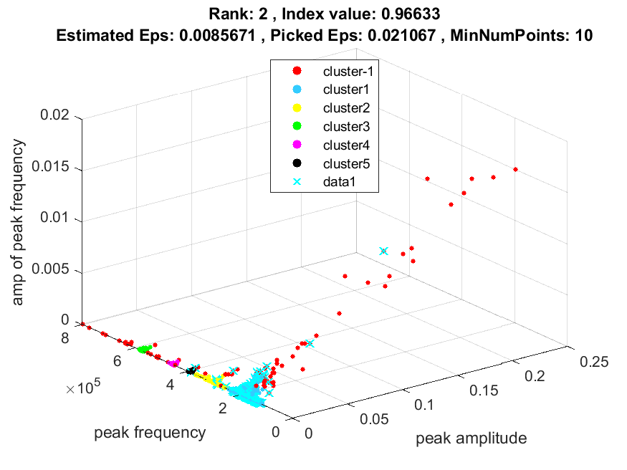
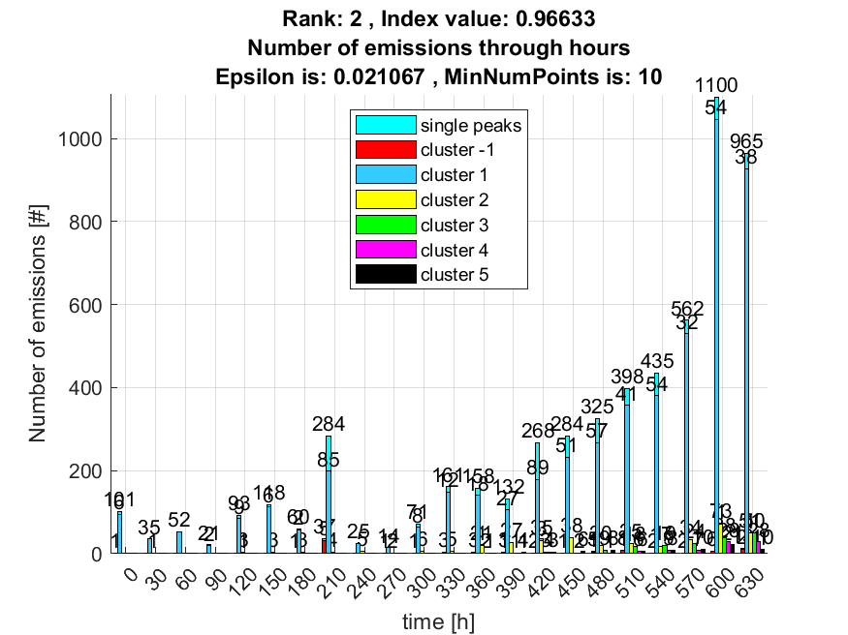

3. result: (pp1, peak_frequency, amp_of_peak_frequency)
Estimated Epsilon: 0.012715, Picked Epsilon: 0.030215, MinNumPoints: 10
DBCV index value: 0.93049
cluster -1 had 0.4918% single peaks
cluster 1 had 97.8689% single peaks
cluster 2 had 1.6393% single peaks
cluster 3 had 0% single peaks
cluster 4 had 0% single peaks
cluster 5 had 0% single peaks
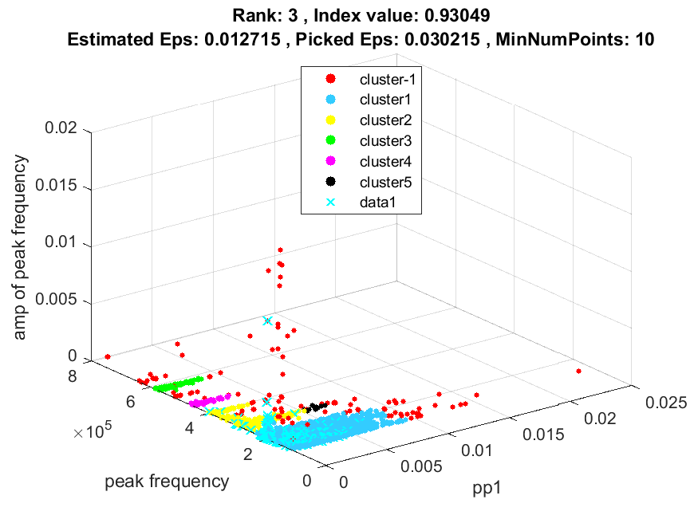
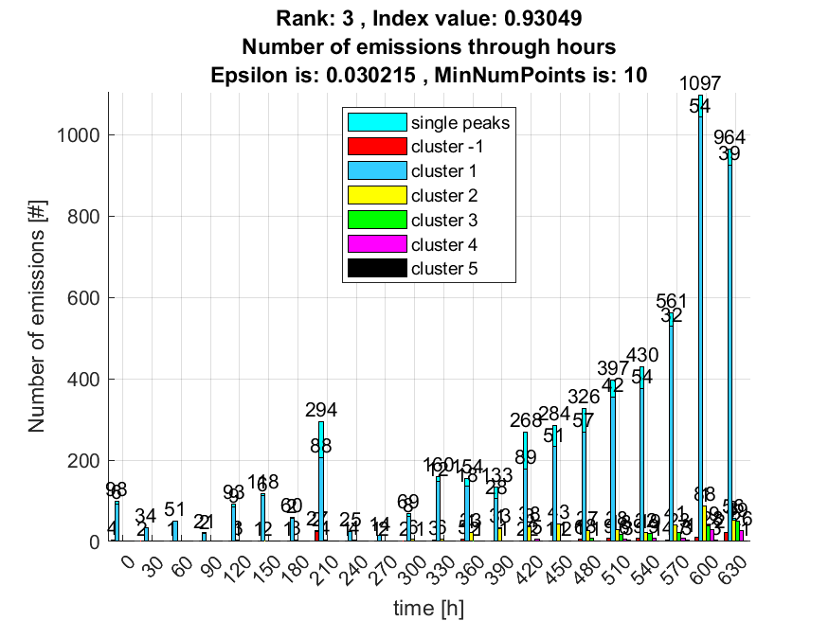

4. result: (rise_time, peak_frequency, amp_of_peak_frequency)
Estimated Epsilon: 0.013128, Picked Epsilon: 0.028128, MinNumPoints: 10
DBCV index value: 0.93007
cluster -1 had 2.1311% single peaks
cluster 1 had 96.2295% single peaks
cluster 2 had 1.3115% single peaks
cluster 3 had 0% single peaks
cluster 4 had 0.32787% single peaks
cluster 5 had 0% single peaks
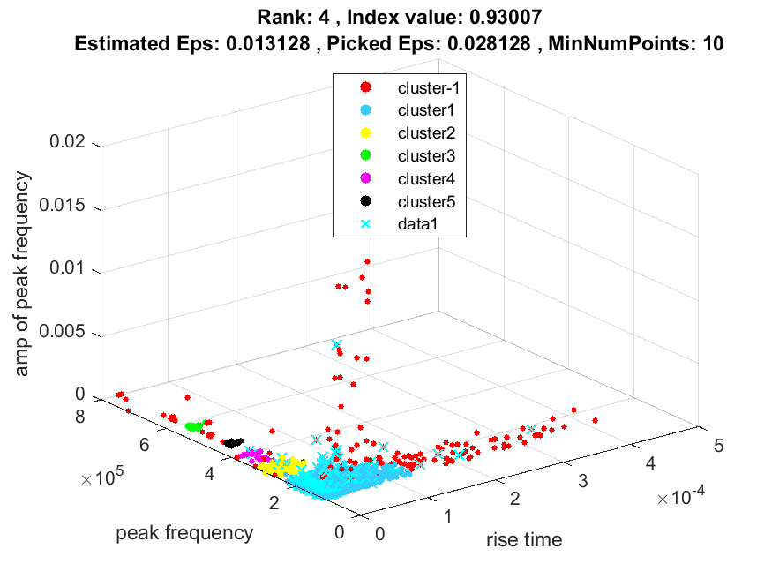
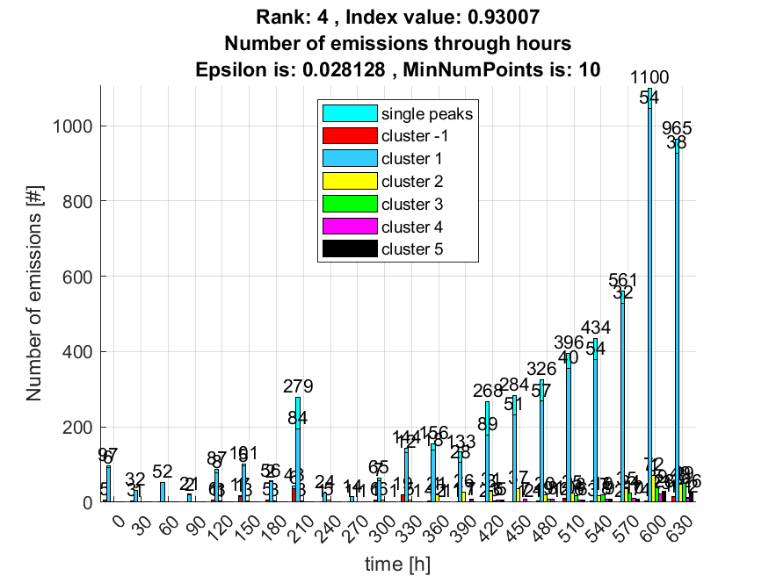

5. result: (rise_time, signal_strength, peak_frequency)
Estimated Epsilon: 0.013295, Picked Epsilon: 0.028295, MinNumPoints: 10
DBCV index value: 0.92962
cluster -1 had 1.9672% single peaks
cluster 1 had 96.3934% single peaks
cluster 2 had 1.3115% single peaks
cluster 3 had 0% single peaks
cluster 4 had 0.32787% single peaks
cluster 5 had 0% single peaks
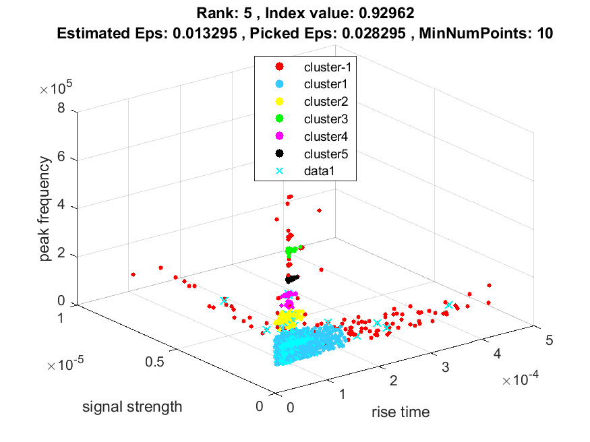
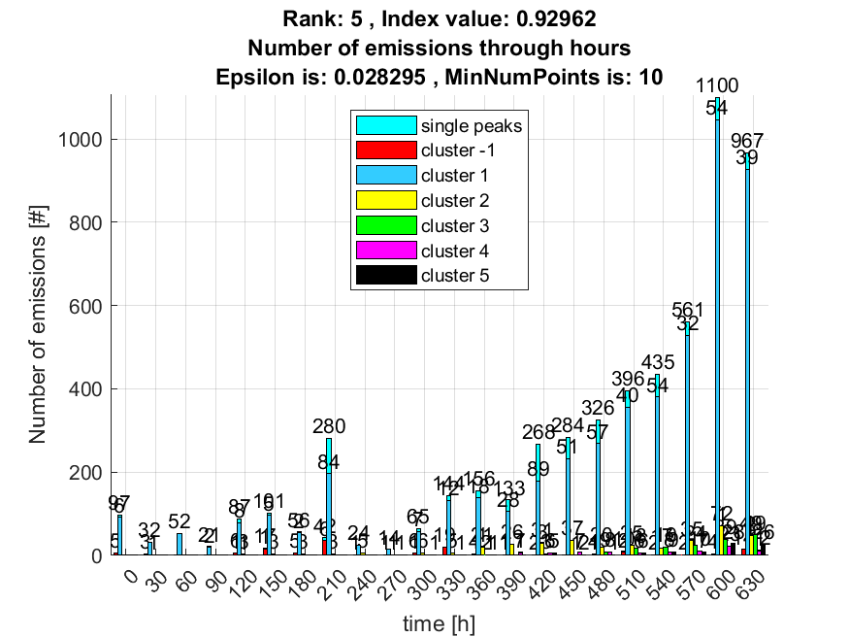

6. result: (signal_strength, centroid_frequency, peak_frequency)
Estimated Epsilon: 0.01697, Picked Epsilon: 0.04197, MinNumPoints: 10
DBCV index value: 0.92949
cluster -1 had 0.4918% single peaks
cluster 1 had 98.0328% single peaks
cluster 2 had 1.1475% single peaks
cluster 3 had 0% single peaks
cluster 4 had 0% single peaks
cluster 5 had 0.32787% single peaks
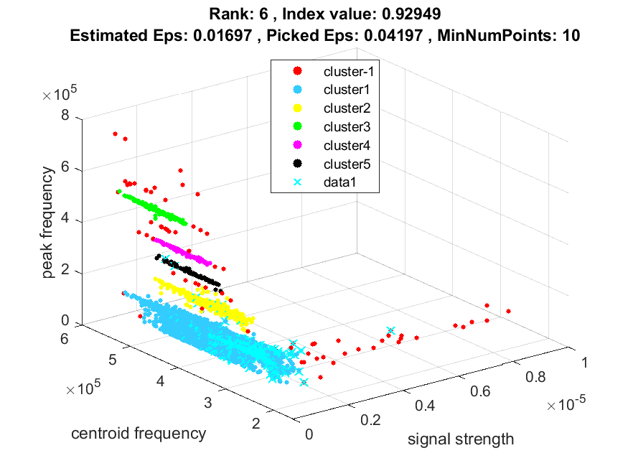
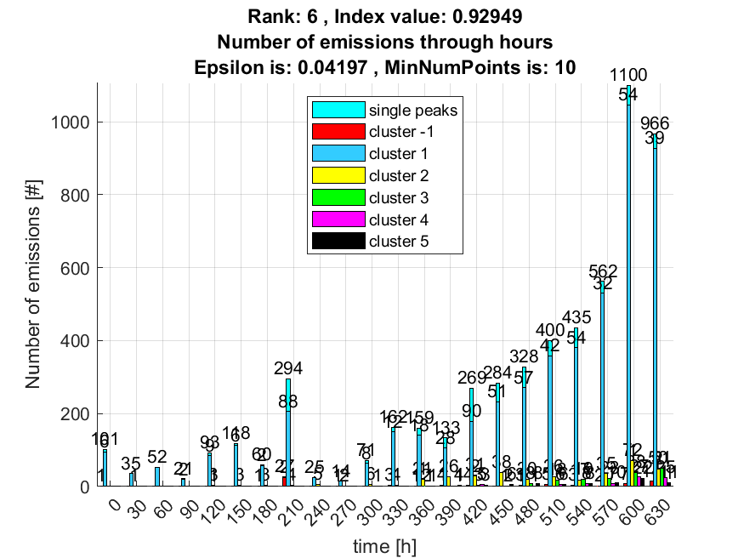

7. result: (signal_strength, pp3, peak_frequency)
Estimated Epsilon: 0.017417, Picked Epsilon: 0.039917, MinNumPoints: 10
DBCV index value: 0.92911
cluster -1 had 1.3115% single peaks
cluster 1 had 98.0328% single peaks
cluster 2 had 0.32787% single peaks
cluster 3 had 0% single peaks
cluster 4 had 0% single peaks
cluster 5 had 0.16393% single peaks
cluster 6 had 0.16393% single peaks
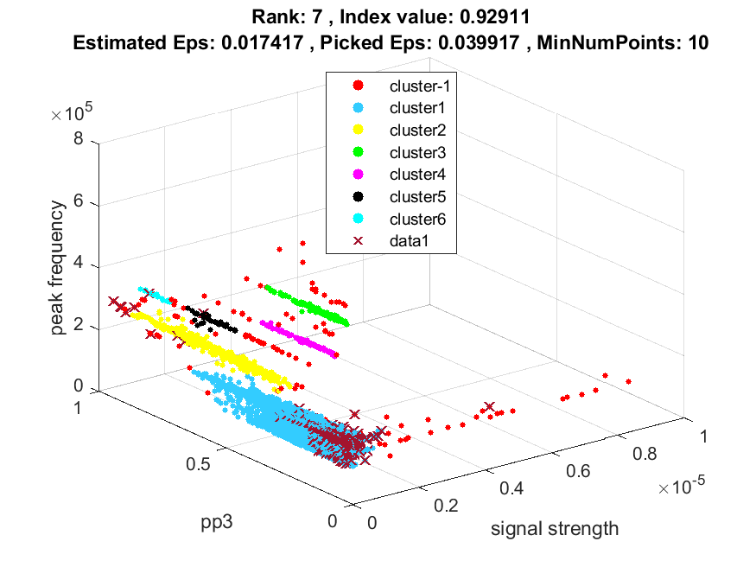
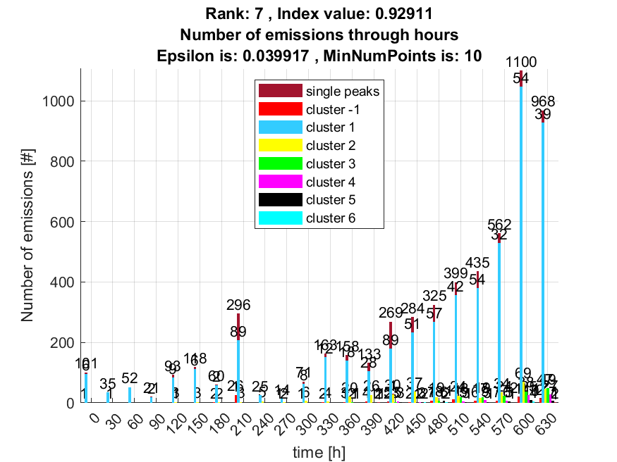

8. result: (pp3, peak_frequency, amp_of_peak_frequency)
Estimated Epsilon: 0.014342, Picked Epsilon: 0.039342, MinNumPoints: 10
DBCV index value: 0.92888
cluster -1 had 1.3115% single peaks
cluster 1 had 98.0328% single peaks
cluster 2 had 0.32787% single peaks
cluster 3 had 0% single peaks
cluster 4 had 0% single peaks
cluster 5 had 0.16393% single peaks
cluster 6 had 0.16393% single peaks
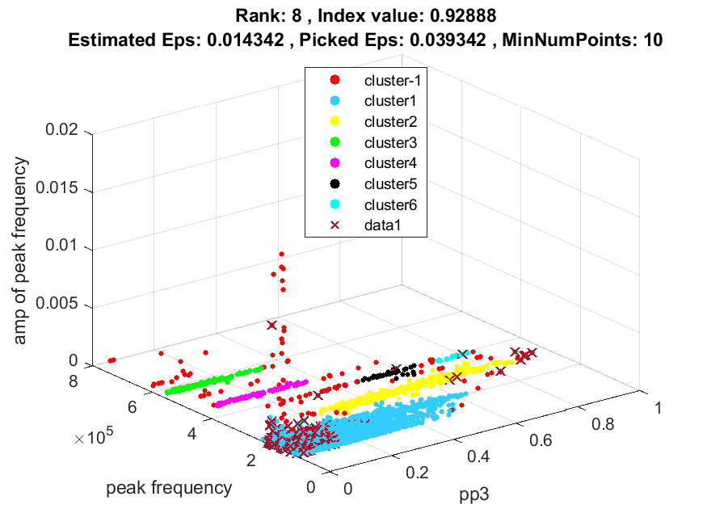
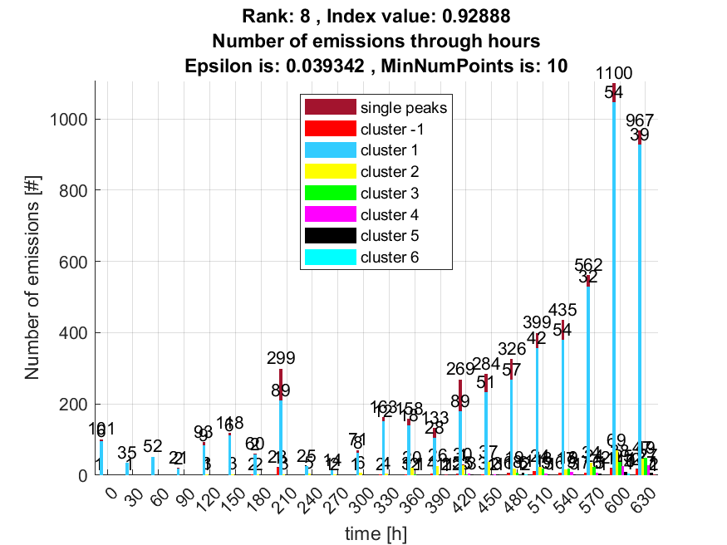

9. result: (centroid_frequency, peak_frequency, amp_of_peak_frequency)
Estimated Epsilon: 0.016101, Picked Epsilon: 0.041101, MinNumPoints: 10
DBCV index value: 0.92859
cluster -1 had 0.4918% single peaks
cluster 1 had 98.0328% single peaks
cluster 2 had 1.1475% single peaks
cluster 3 had 0% single peaks
cluster 4 had 0% single peaks
cluster 5 had 0.32787% single peaks
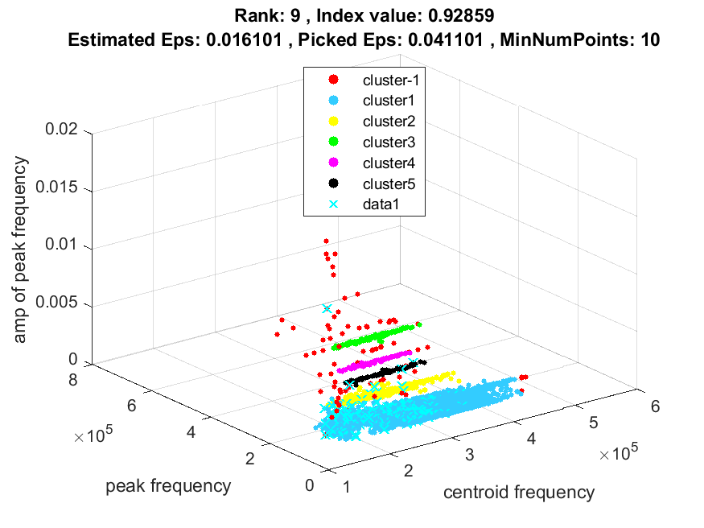
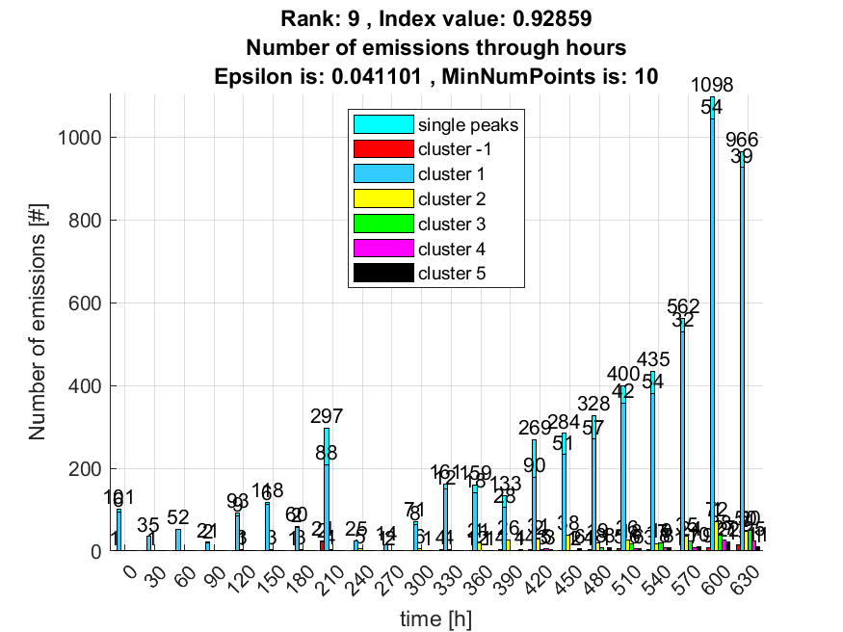

10. result: (peak_amplitude, pp3, peak_frequency)
Estimated Epsilon: 0.018447, Picked Epsilon: 0.040947, MinNumPoints: 10
DBCV index value: 0.92796
cluster -1 had 1.3115% single peaks
cluster 1 had 98.0328% single peaks
cluster 2 had 0.32787% single peaks
cluster 3 had 0% single peaks
cluster 4 had 0% single peaks
cluster 5 had 0.16393% single peaks
cluster 6 had 0.16393% single peaks
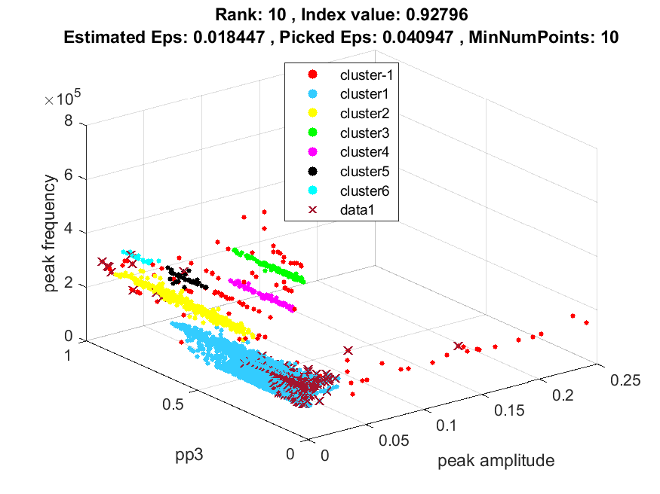
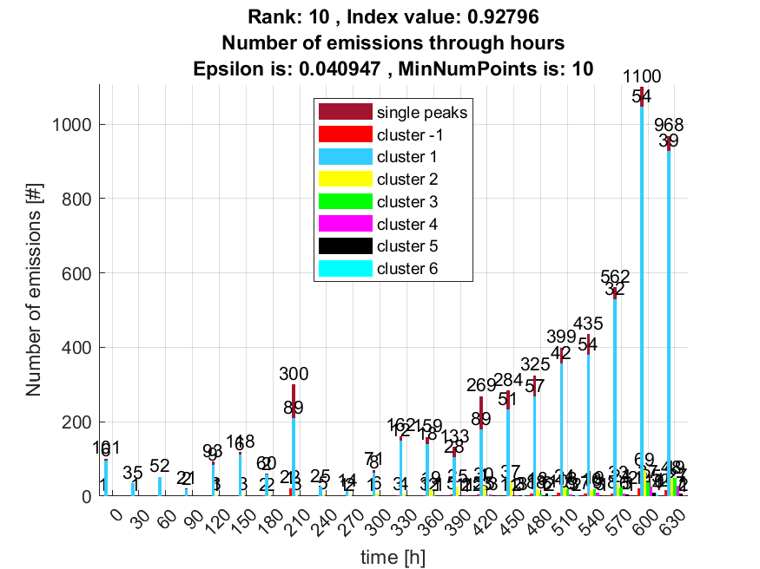
Kao dodatna informacija priložio sam sličnosti navedenih 10 rezultata kao postotak sličnosti svih clustera između svih parova rezultata. Gdje je svaki red i svaki stupac predstavlja određeni cluster navedenog rangiranog rezultata. Clusteri idu po redu kako su označeni na slici uključujući outliere kao cluster označen s -1.

Intersection between rank 1 and rank 2 :
0.9125 0.0002 0 0 0 0 0
0.0002 0.9998 0 0 0 0 0
0.0132 0 0.9579 0 0 0 0.0289
0.0061 0 0 0.9939 0 0 0
0 0 0 0 1.0000 0 0
0 0 0 0 0 1.0000 0

Intersection between rank 1 and rank 3 :
0.0117 0 0.0230 0
0.9263 0 0 0
0.0619 0 0 0
0 1.0000 0 0
0.0002 0 0.9770 0
0 0 0 1.0000

Intersection between rank 1 and rank 4 :
1 0 0 0 0 0
0 1 0 0 0 0
0 0 1 0 0 0
0 0 0 1 0 0
0 0 0 0 1 0
0 0 0 0 0 1

Intersection between rank 1 and rank 5 :
1 0 0 0 0 0
0 1 0 0 0 0
0 0 1 0 0 0
0 0 0 1 0 0
0 0 0 0 1 0
0 0 0 0 0 1

Intersection between rank 1 and rank 6 :
0.0114 0.0060 0.0230
0.9151 0 0
0.0611 0 0
0 0.9940 0
0.0002 0 0.9770
0.0122 0 0

Intersection between rank 1 and rank 7 :
0.0114 0.0060 0.0230
0.9151 0 0
0.0611 0 0
0 0.9940 0
0.0002 0 0.9770
0.0122 0 0

Intersection between rank 1 and rank 8 :
0.0114 0.0060 0.0230
0.9151 0 0
0.0611 0 0
0 0.9940 0
0.0002 0 0.9770
0.0122 0 0

Intersection between rank 1 and rank 9 :
0.0114 0.0060 0.0230
0.9151 0 0
0.0611 0 0
0 0.9940 0
0.0002 0 0.9770
0.0122 0 0

Intersection between rank 1 and rank 10 :
0.0114 0.0060 0.0230
0.9151 0 0
0.0611 0 0
0 0.9940 0
0.0002 0 0.9770
0.0122 0 0

Intersection between rank 2 and rank 3 :
0.0125 0.0061 0.0230 0
0.9263 0 0 0
0.0593 0 0 0
0 0.9939 0 0
0.0002 0 0.9770 0
0 0 0 1.0000
0.0018 0 0 0

Intersection between rank 2 and rank 4 :
0.9125 0.0002 0.0132 0.0061 0 0
0.0002 0.9998 0 0 0 0
0 0 0.9579 0 0 0
0 0 0 0.9939 0 0
0 0 0 0 1.0000 0
0 0 0 0 0 1.0000
0 0 0.0289 0 0 0

Intersection between rank 2 and rank 5 :
0.9125 0.0002 0.0132 0.0061 0 0
0.0002 0.9998 0 0 0 0
0 0 0.9579 0 0 0
0 0 0 0.9939 0 0
0 0 0 0 1.0000 0
0 0 0 0 0 1.0000
0 0 0.0289 0 0 0

Intersection between rank 2 and rank 6 :
0.0122 0.0120 0.0230
0.9151 0 0
0.0585 0 0
0 0.9880 0
0.0002 0 0.9770
0.0122 0 0
0.0018 0 0

Intersection between rank 2 and rank 7 :
0.0122 0.0120 0.0230
0.9151 0 0
0.0585 0 0
0 0.9880 0
0.0002 0 0.9770
0.0122 0 0
0.0018 0 0

Intersection between rank 2 and rank 8 :
0.0122 0.0120 0.0230
0.9151 0 0
0.0585 0 0
0 0.9880 0
0.0002 0 0.9770
0.0122 0 0
0.0018 0 0

Intersection between rank 2 and rank 9 :
0.0122 0.0120 0.0230
0.9151 0 0
0.0585 0 0
0 0.9880 0
0.0002 0 0.9770
0.0122 0 0
0.0018 0 0

Intersection between rank 2 and rank 10 :
0.0122 0.0120 0.0230
0.9151 0 0
0.0585 0 0
0 0.9880 0
0.0002 0 0.9770
0.0122 0 0
0.0018 0 0

Intersection between rank 3 and rank 4 :
0.0117 0.9263 0.0619 0 0.0002 0
0 0 0 1.0000 0 0
0.0230 0 0 0 0.9770 0
0 0 0 0 0 1.0000

Intersection between rank 3 and rank 5 :
0.0117 0.9263 0.0619 0 0.0002 0
0 0 0 1.0000 0 0
0.0230 0 0 0 0.9770 0
0 0 0 0 0 1.0000

Intersection between rank 3 and rank 6 :
0.9878 0.0002 0
0 0.9940 0
0 0 1.0000
0.0122 0 0

Intersection between rank 3 and rank 7 :
0.9878 0.0002 0
0 0.9940 0
0 0 1.0000
0.0122 0 0

Intersection between rank 3 and rank 8 :
0.9878 0.0002 0
0 0.9940 0
0 0 1.0000
0.0122 0 0

Intersection between rank 3 and rank 9 :
0.9878 0.0002 0
0 0.9940 0
0 0 1.0000
0.0122 0 0

Intersection between rank 3 and rank 10 :
0.9878 0.0002 0
0 0.9940 0
0 0 1.0000
0.0122 0 0

Intersection between rank 4 and rank 5 :
1 0 0 0 0 0
0 1 0 0 0 0
0 0 1 0 0 0
0 0 0 1 0 0
0 0 0 0 1 0
0 0 0 0 0 1

Intersection between rank 4 and rank 6 :
0.0114 0.0060 0.0230
0.9151 0 0
0.0611 0 0
0 0.9940 0
0.0002 0 0.9770
0.0122 0 0

Intersection between rank 4 and rank 7 :
0.0114 0.0060 0.0230
0.9151 0 0
0.0611 0 0
0 0.9940 0
0.0002 0 0.9770
0.0122 0 0

Intersection between rank 4 and rank 8 :
0.0114 0.0060 0.0230
0.9151 0 0
0.0611 0 0
0 0.9940 0
0.0002 0 0.9770
0.0122 0 0

Intersection between rank 4 and rank 9 :
0.0114 0.0060 0.0230
0.9151 0 0
0.0611 0 0
0 0.9940 0
0.0002 0 0.9770
0.0122 0 0

Intersection between rank 4 and rank 10 :
0.0114 0.0060 0.0230
0.9151 0 0
0.0611 0 0
0 0.9940 0
0.0002 0 0.9770
0.0122 0 0

Intersection between rank 5 and rank 6 :
0.0114 0.0060 0.0230
0.9151 0 0
0.0611 0 0
0 0.9940 0
0.0002 0 0.9770
0.0122 0 0

Intersection between rank 5 and rank 7 :
0.0114 0.0060 0.0230
0.9151 0 0
0.0611 0 0
0 0.9940 0
0.0002 0 0.9770
0.0122 0 0

Intersection between rank 5 and rank 8 :
0.0114 0.0060 0.0230
0.9151 0 0
0.0611 0 0
0 0.9940 0
0.0002 0 0.9770
0.0122 0 0

Intersection between rank 5 and rank 9 :
0.0114 0.0060 0.0230
0.9151 0 0
0.0611 0 0
0 0.9940 0
0.0002 0 0.9770
0.0122 0 0

Intersection between rank 5 and rank 10 :
0.0114 0.0060 0.0230
0.9151 0 0
0.0611 0 0
0 0.9940 0
0.0002 0 0.9770
0.0122 0 0

Intersection between rank 6 and rank 7 :
1 0 0
0 1 0
0 0 1

Intersection between rank 6 and rank 8 :
1 0 0
0 1 0
0 0 1

Intersection between rank 6 and rank 9 :
1 0 0
0 1 0
0 0 1

Intersection between rank 6 and rank 10 :
1 0 0
0 1 0
0 0 1

Intersection between rank 7 and rank 8 :
1 0 0
0 1 0
0 0 1

Intersection between rank 7 and rank 9 :
1 0 0
0 1 0
0 0 1

Intersection between rank 7 and rank 10 :
1 0 0
0 1 0
0 0 1

Intersection between rank 8 and rank 9 :
1 0 0
0 1 0
0 0 1

Intersection between rank 8 and rank 10 :
1 0 0
0 1 0
0 0 1

Intersection between rank 9 and rank 10 :
1 0 0
0 1 0
0 0 1

